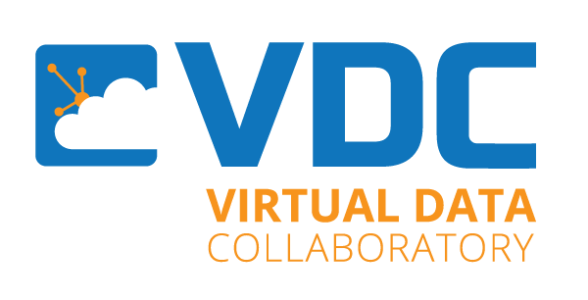
VDC Data Science Workshop
Agenda
November 12 &13, 2020

November 12 (Day 1) 1:00 pm -4:00 pm
1:00 - Introductions
Forough Ghahramani, EdD, Associate Vice President for Research, Innovation, and Sponsored Programs
1:15 - Introduction to Data Science
Vasant Honavar, PhD - Professor and Edward Frymoyer Chair of Information Sciences and Technology, Penn State
Daniel Balouek-Thomert, PhD- Research Associate and Lecturer, Rutgers Discovery Informatics Institute, Rutgers University
2:00 - Data Exploration
Ryan Womack – Data Librarian, Rutgers University
4:00 Amazon Gift Card drawings (2 students will be selected)
November 13 (Day 2) 9:00 -12:00
9:00- 11:00 Machine Learning hands-on
John Yen, PhD, Professor and Director of Strategic Research initiatives, College of Information Sciences and Technology, Penn State University
11:00 AM - Data Science Career panel
Forough Ghahramani, EdD, Associate Vice President for Research and Innovation, EDGE
Laura Glotzbach, Founder and President, LGS Marketing Services
Mark McKoy, Vice President of Operations, Aqua
Laila Rehan, Strategic Go to Market Leader and Client Partner IQVIA
Sven Serneels,PhD Senior Director, Aspen Technologies
12:00 Amazon Gift Card drawings (2 students will be selected)

